Update BIOS from EFI Shell

一、If our miniPC is 64 bit BIOS，BIOS update from EFI shell as below:：
- Put the BIOS file under the”EFI64” folder；
- Put the “EFI64” folder under the root path of the U-disk:
- Connect to U-disk to our MiniPC，connect USB mouse and Keyboard to Mini PC with USB hub; power on MiniPC and press power button F7 continuously, then we will see below menu, and choose UEFI:Built-in EFI shell，and enter “EFI Shell” Menu；
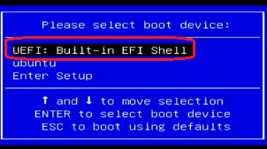
- Input fs1: [this step is to enter the U-disk， fs0 normally is the flash in MiniPC itself, and the U-disk normally is fs1 or fs2, it depends the fact.]
Input ls [to check the folder in U-disk]
Input cd EFI64 [enter the “EFI64” folder]
Input fpt64.efi -f files.bin -rewrite [starting to update the 64 Bit BIOS，untill the BIOS update finished. “files.bin” is the name of BIOS]
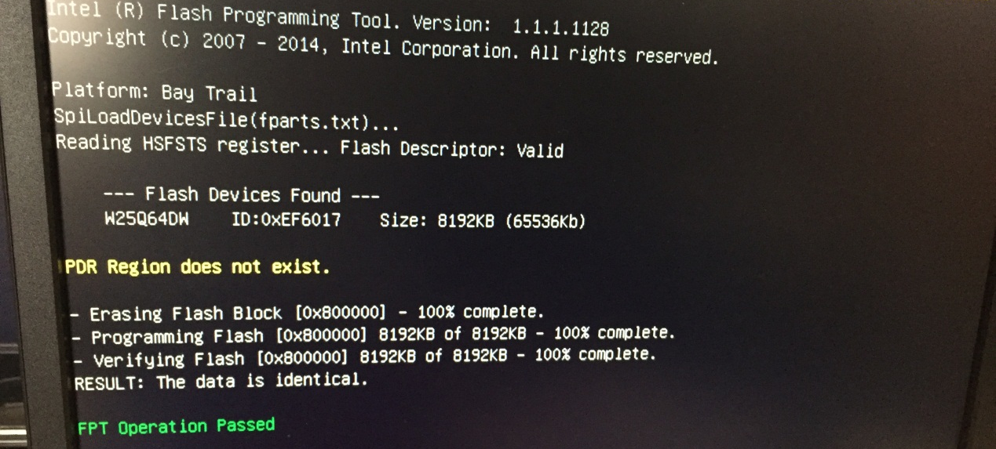

二、Check our miniPC and see if the BIOS is 32Bit or 64Bit:
Power on and start up, press F7 of keyboard continuously, choose Enter Setup, and then enter BIOS setting menu；
In “BIOS Setting->Main->Project Version” ， if shows “X64”, it means 64Bit BIOS；if no “X64”, it means 32Bit BIOS.
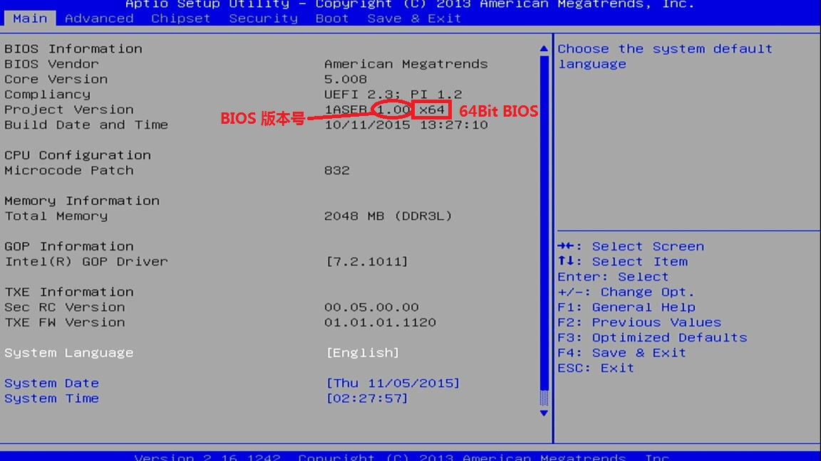

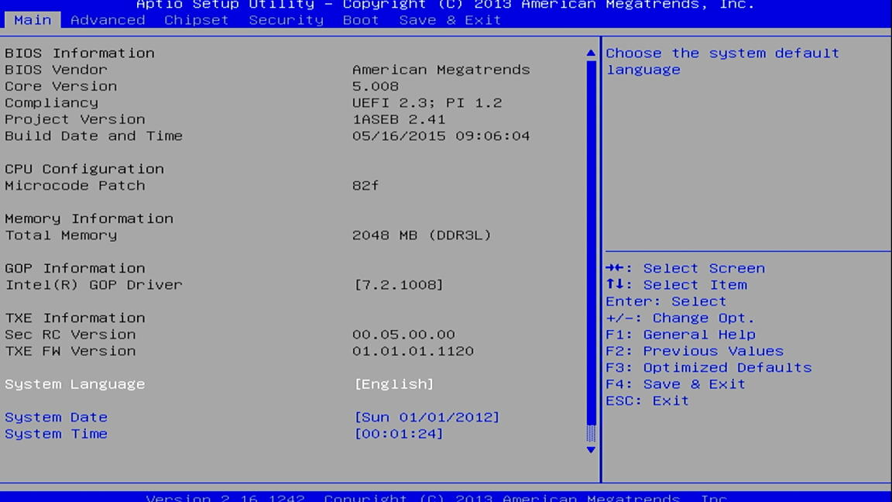

How to switch to 32 Bit Ubuntu OS of miniPC
Brief step:：
①Firstly update 32/64Bit BIOS for minipc;

②Install Ubuntu OS version (if our minipc is 32Bit, then use 32Bit BISO and 32Bit Ubuntu system; if our minipc is 64Bit, then use 64Bit BIOS and 64Bit Ubuntu system).

③Install patch, this step need to connect to the internet all the time; after finishing, we need to reboot the minipc.

④change the main display to HDMI.

