Guest Pager 1500
Guest pager is a new development to facilitate communication within a company, e.g., in a restaurant or a logistics company. It is a multifunctional pager system that can communicate in two directions.

Components
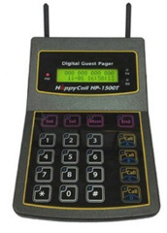 | 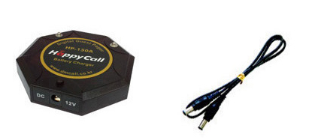 | 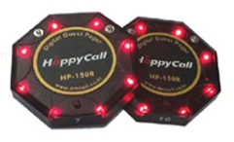
Transmitter  HP-1500 | Charging station  HP-150A | Pager  HP-150R

Functionality
Transmitter HP-1500 can send four different signals to the pagers.
1. Blinking. 2. Voice and blinking. 3. Vibration and blinking. 4. Voice, vibration and blinking.
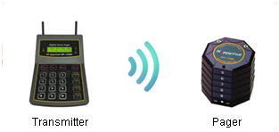
HP-1500 can also be used as a receiver for HC transmitters (see Happy Call System). In this case, HP-1500 works as a receiver. This is made possible through its two antennas, which can receive signals and send signals.
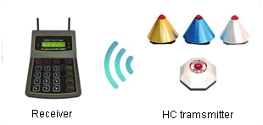
HP-1500 as a receiver works like the Happy Call System. For example, in the restaurant: Guests can use their HC transmitter bellss at any time to call the waiter/bar to order more drinks. In this way, you avoid long waiting times and can significantly improve your service. Similarly, you can use HP-1500 in other companies (logistics, warehouse, office...)

Advantages of HP-1500T Guest Pager Systems:
• Two call systems in one (joint transmitter and receiver in one)
• Components can be extended at a later stage.
• Fast wireless communication.
• Small, lightweight components with an elegant design.
• Easy installation.

Installation
- Connect the transmitter with an electrical outlet.
- Connect the charging station and the transmitter with the provided cable.
- Insert pager number and charge pager.
- If applicable, insert HC transmitter numbers.
- Done.

Technical specification
System | : Digital wireless call system
Frequency | : 869.400 - 869.650 MHz
Operating frequency | : 869.500 MHz
Transmission power | : 20 mW
Power supply (Transmitter) | : Adapter 230V AC/DC 12V
Power supply (Charger) | : DC 12V
Power supply (Pager) | : DC 3,7V
Ambient temperature | : -10 ~ +40°
Range | : ca. 600 outdoor, up to 100 m indoor.

How you can use Guest Pager

